* **Job failed error came on Slack**

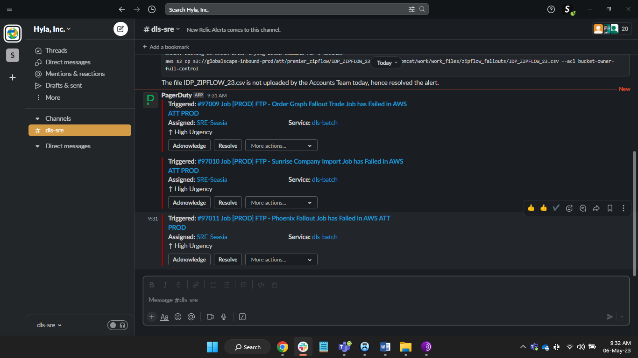

* **Acknowledge The Alert in PagerDuty**

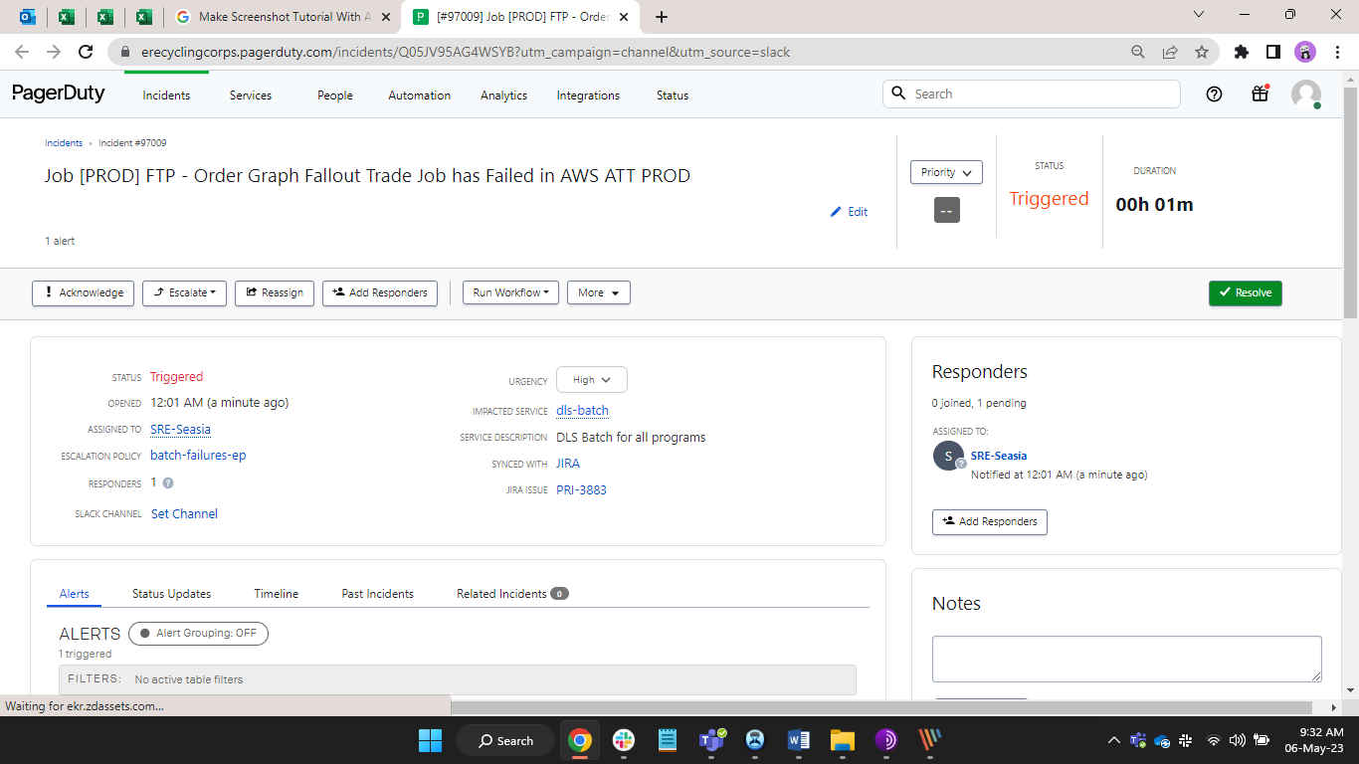

* **After** **Acknowledge Alert are look like this on PagerDuty.**

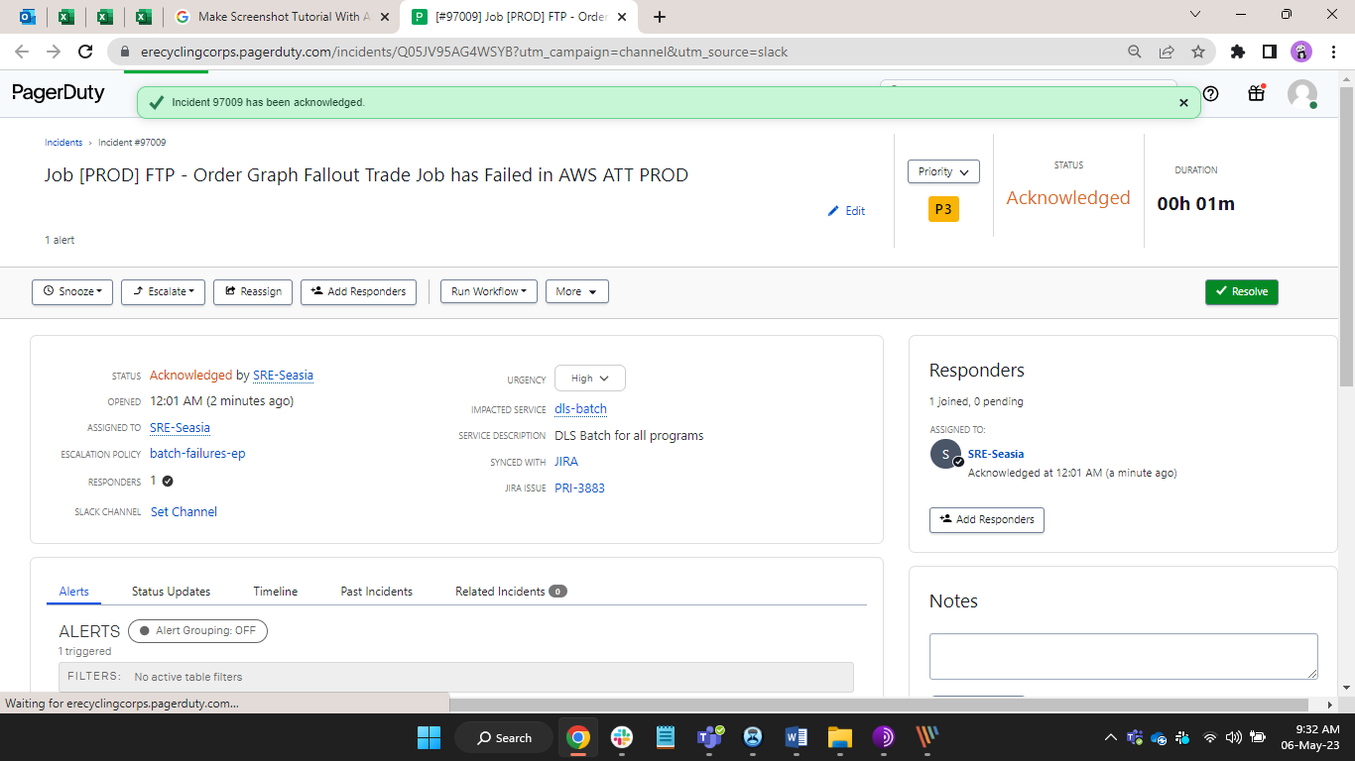

* **After** **Acknowledge Alert are look like this on Slack.**

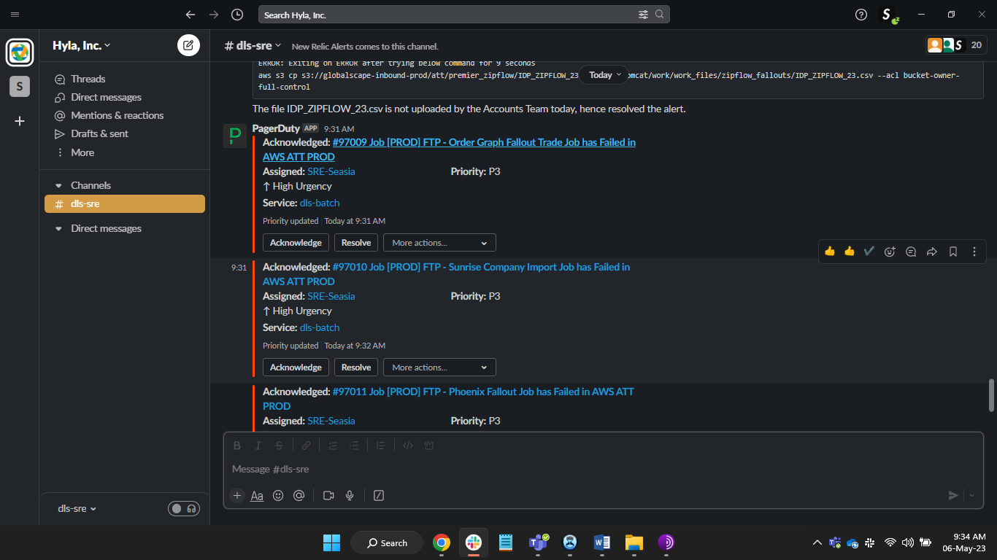

* **View Logs on PagerDuty**

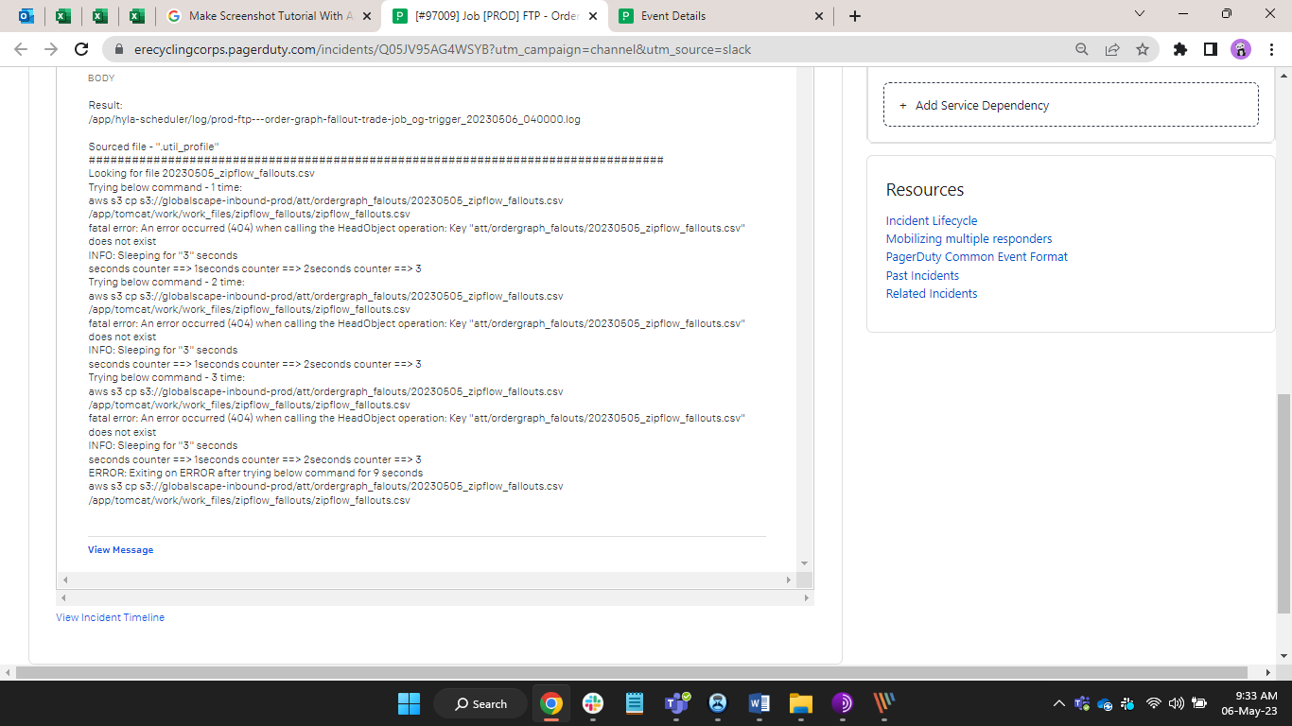

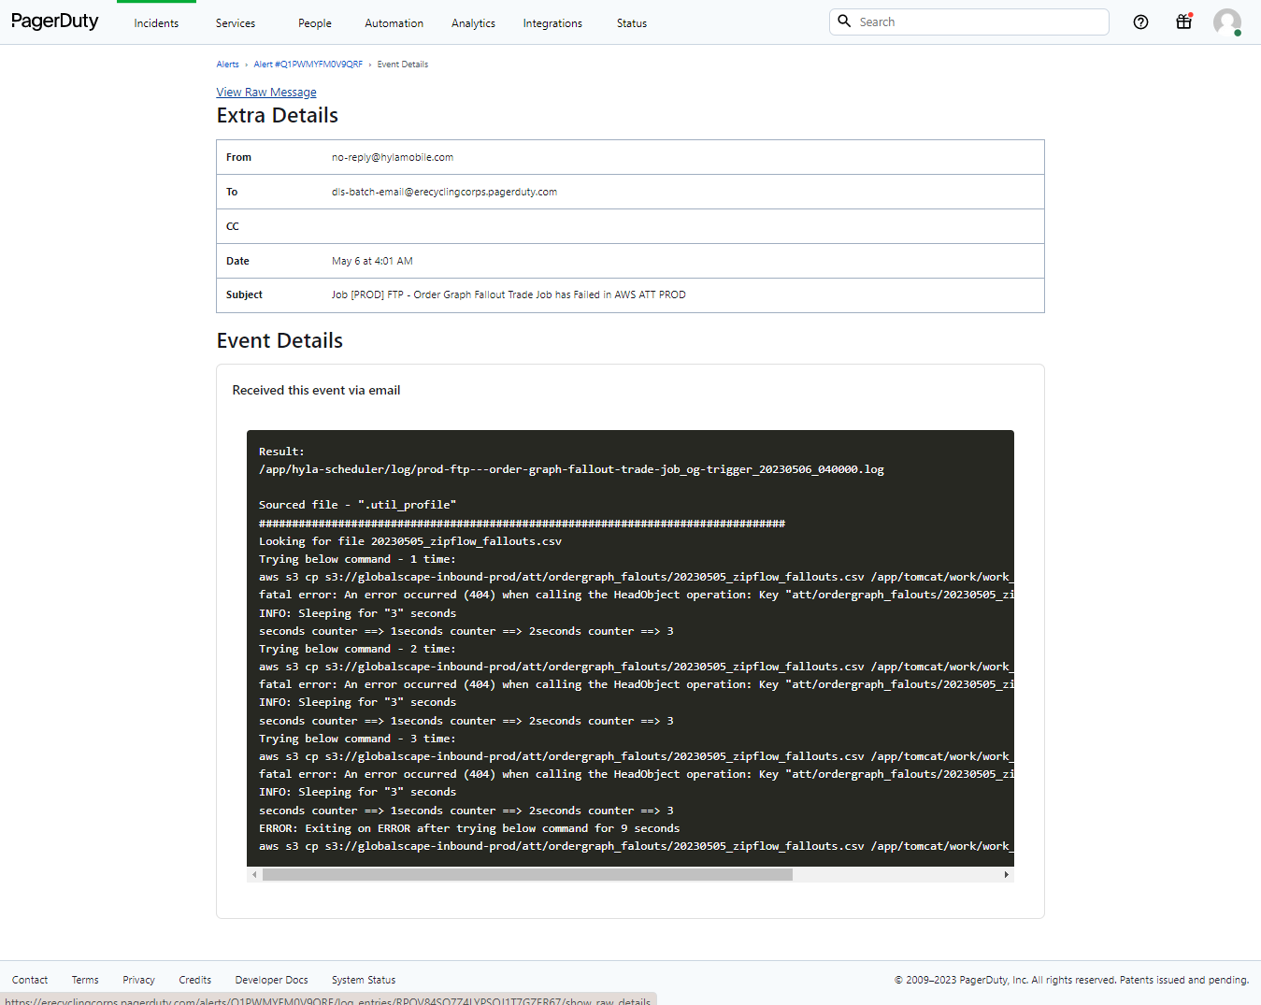

**( NOTE – check previous History of the Jobs on Slack and when job are regular failed then make it resolved by adding resolution and when the job are unexpected and escalated on level 2 )**

* **View Job Frailer On Quart Desk**

**Ex. - 97011 Job [PROD] FTP - Phoenix Fallout Job has Failed in AWS ATT PROD**

1. **Select ATT and Search Phoenix Fallout Job and check Health and Execution History.**

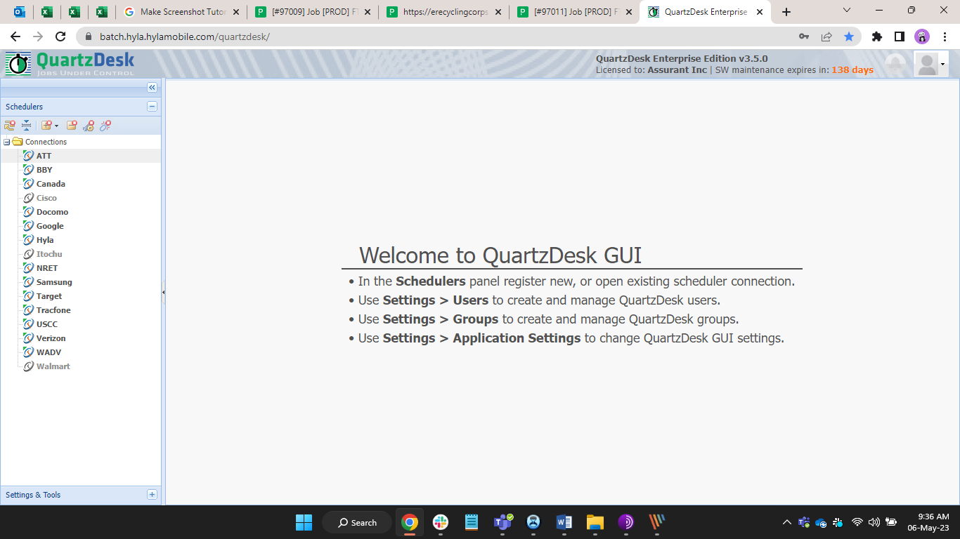

* **Check Frailer Date Time and Duration**

**Note – When job are failed show like a red box and when job are run then show as a green box**

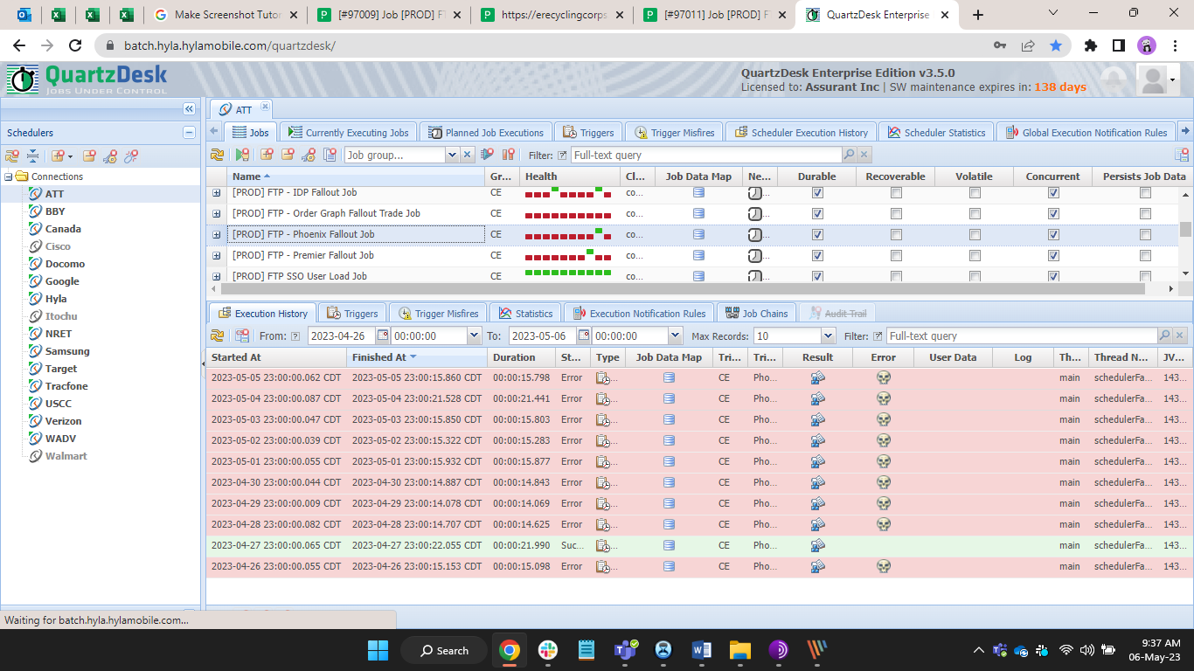

* **Click on resolved and add resolution note in this box that given by the DevOps team or as per jira Runbook.**
* **If the Job are unexpected then in resolution note write “leve2” and make it resolved for creating jira ticket for DevOps Team.**

